**Enterprise Resource Planning**

**Training User Manual**

**VERSION 12.0.0**

**Purchase**

* **Purchase**
  1. [Direct GRN](http://192.168.1.17:8080/zab/login?screen=podrgrnheader&option=Direct+GRN&menuname=po)
  2. [Purchase Order](http://192.168.1.17:8080/zab/login?screen=poordheader&option=Purchase+Order&menuname=po)
  3. [Create GRN](http://192.168.1.17:8080/zab/login?screen=poordheaderim&option=Create+GRN&menuname=po)
  4. [GRN Return](http://192.168.1.17:8080/zab/login?screen=pocrnheader&option=GRN+Return&menuname=po)
  5. [Codes & Parameter](javascript:run1()&menuname=pocodes)
  6. [Reports](javascript:run1()&menuname=poreports)

# Direct GRN

**> GRN Header**

|  |  |
| --- | --- |
| **Step 1** | Open System **>** Purchase **>** Direct GRN |
| **Step 2** | Select Supplier ID from side list, select Purchase Type, write Supplier Bill No. & Challan No. in the field. |
| **Step 3** | Click **Add** |
| **Result** | A new GRN will be created. |

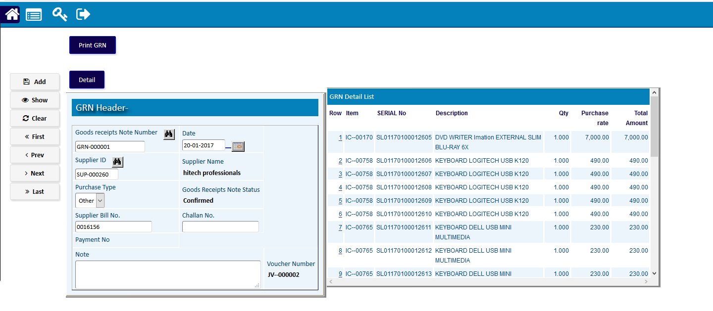

**> GRN Detail**

|  |  |
| --- | --- |
| **Step 1** | Click **Detail** |
| **Step 2** | Select Item Code, Serial Number & fill other fields. |
| **Step 3** | Click **Add** |
| **Step 4** | Follow step 2 & 3 for multiple entry. |
| **Result** | The details of Products for the GRN will be added. |

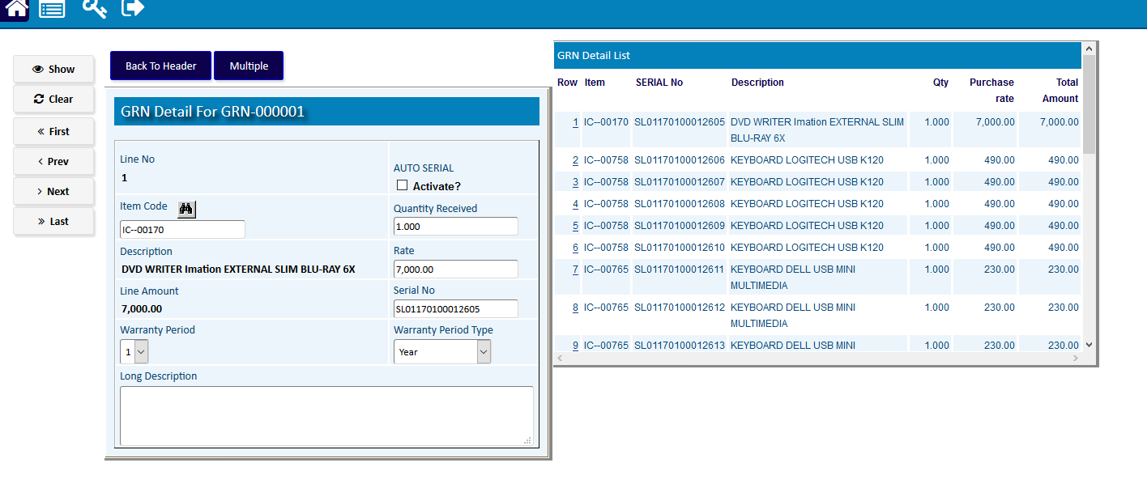

# purchase ORDER

* Purchase Order Header

|  |  |
| --- | --- |
| **Step 1** | Open System **>** PurchaseOrder |
| **Step 2** | Select Customer number from side list or choose purchase type. |
| **Step 3** | Click **Add** |
| **Result** | PO will be created. |

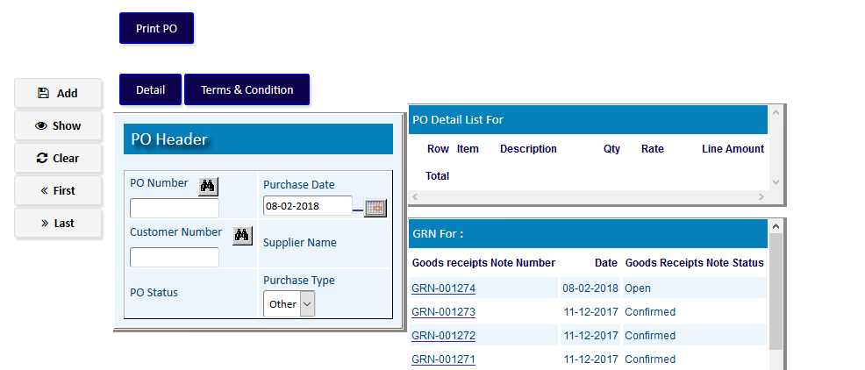

* Purchase Order Detail

|  |  |
| --- | --- |
| **Step 1** | Click Detail |
| **Step 2** | Select the desired item by clicking on the item code from the side list & write qty & price |
| **Step 3** | Click **Add** |
| **Step 4** | Repeat Step 2 and 3 for adding multiple products |
| **Step 5** | Click Complete when done |
| **Result** | PO created. |

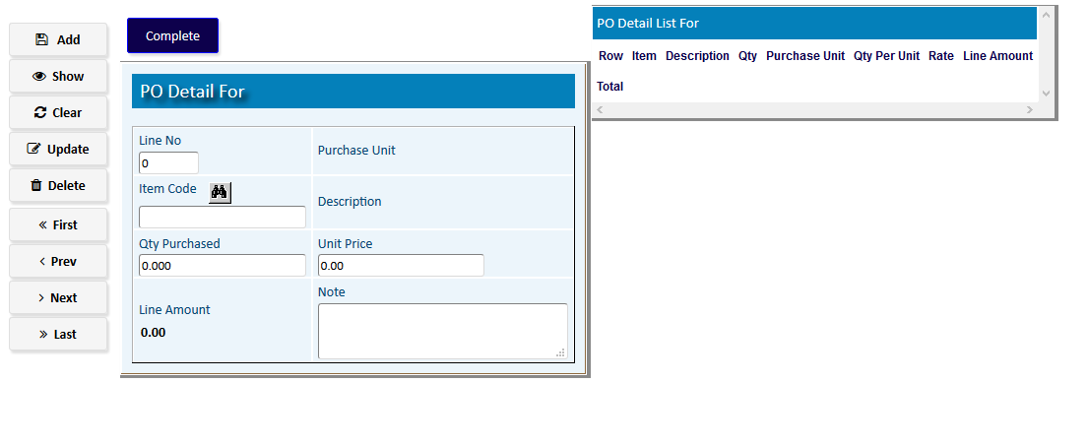

# Create GRN (Against PO)

## Header Entry

|  |  |
| --- | --- |
| **Step 1** | Open System **>** Purchase **>** [create](http://localhost:8080/zab/login?screen=poadvadjheader&option=Purchase+Advance+Adjustment) GRN |
| **Step 2** | Select PO number & supplier number |
| **Step 3** | Click **Create GRN**. |
| **Result** | GRN will be created against the PO |

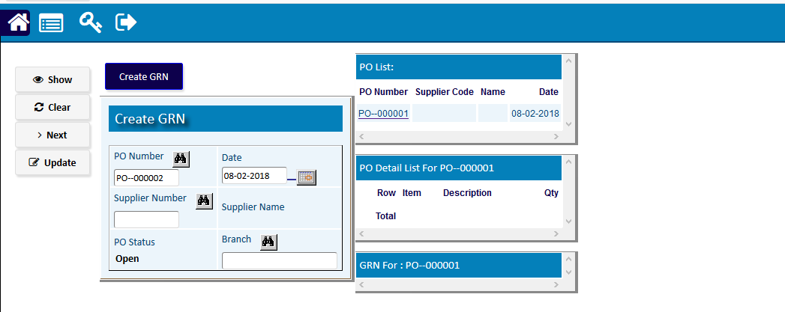

# 

# [GRN Return](http://192.168.1.17:8090/zab/login?screen=opcrnheader&option=Sales+Return&menuname=op)

## GRN Return Header

|  |  |  |
| --- | --- | --- |
| **Step 1** |  | Open System **>** Purchase **>** GRN Return |
| **Step 2** |  | Select GRN no. & challan no. |
| **Step 3** |  | Click **Add** |
| **Result** |  | New GRN Return entry |

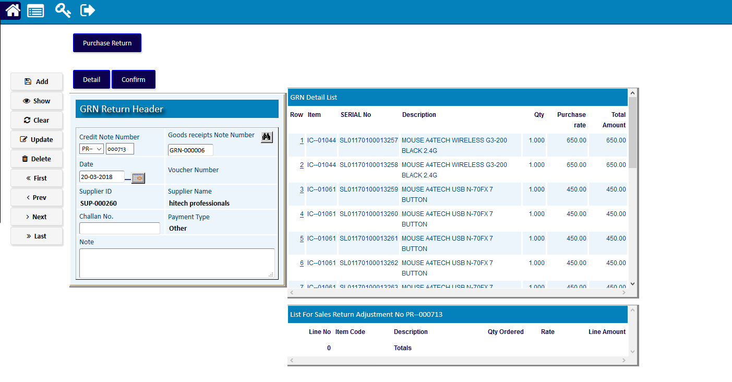

## Sales Return Detail

|  |  |
| --- | --- |
| **Step 1** | Click Detail |
| **Step 2** | Select Product code, Serial & Returned Quantity |
| **Step 3** | Click Add |
| **Step 4** | Repeat Step 2 to 3 for adding multiple products |
| **Step 5** | Click **Return** to return to SR header |
| **Step 6** | Click **Confirm** to confirm the SR. |
| **Note** | GRN return cannot be changed after confirmation. |
| **Result** | New GRN Return creation complete |

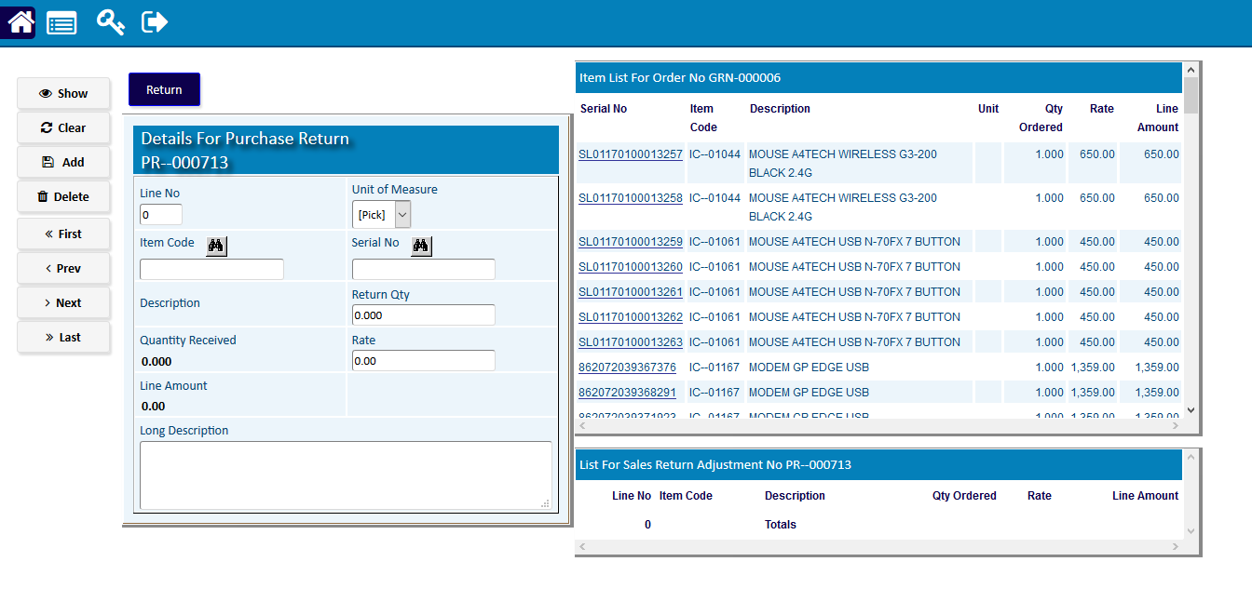

# Codes & Parameter

|  |  |  |
| --- | --- | --- |
| **Step 1** |  | Open System **>** Purchase **>** Codes & Parameter (Open any screen to entry Code) |
| **Step 2** |  | Write code name & check the Activate box. Fill other fields if required. |
| **Step 3** |  | Click **Add** |
| **Result** |  | New Code entry |

